**OnliNE SYSTEM SHOPPING MANAGEMENT**

Project members:

Deepak kumar Adiga 1PI13IS406

Harshavardhan S Nayak 1PI13IS407

**-:CONTENTS:-**

1. Abstract
2. Introduction

* Problem Statement

1. Objective
2. Technology Used

* HTML

1. Requirements

* External Interface
* Hardware
* Software

**-:ABSTRACT:-**

This document brief up the project titled “OnliNE SYSTEM SHOPPING MANAGEMENT”. The main objective of our project is to provide user a online experience of buying the computers. This project helps the user to check the rates on the net and compare them, and also view and purchase more products as that are related to computers like accessories and everything.

This project gives a clear user Interface as to what detail the user requires about every computer present in stock and also every details of the accessories etc...,

**-:INTRODUCTION:-**

This site will be developed to make the shopping of computers online. The site will be developed to help the user and also the seller. Any user can just use the net and shop for computers and also this reduces the load of seller on interacting with the customers.

In the present system the computers are purchased manually by visiting the shop. So there is a need of automating the existing system by providing software solution for it. So that there is ease of shopping for the user in their busy life. By visualizing and experiencing all these problems, we felt it would be better to provide a solution for this problem. This was the basic reason for taking up this problem.

**Problem Statement:**

The main aim of developing this project is to automate the process of shopping computer. It also provides the seller with every record automated and avoids the interaction with the customers to convince the rate and all. It also provides user to choose every product in the site and also can purchase many products simultaneously.

A user can view his/her details about product or buy a product by logging in using name and password

**-:Objectives:**

* The main purpose of using this new system is to provide, the ease of shopping and selling for both customer and seller .
* The objective of this new system is to provide easy access to the world of shopping.
* This system provides security, backup of the data for seller.

-**:Technology Used:**-

**WEB PROGRAMMING MODEL:**

The idea of using the Web as an application environment developed over time, with each stage of technology serving as a springboard for new ideas.

**HTML:**

HTML means Hypertext Markup Language. HTML is a method of describing the format of documents, which allows them to be viewed on computer screens. Web browsers, programs that can navigate across networks and display a wide variety of types of information, display HTML documents. HTML pages can be developed to be simple text or to be complex multimedia extravaganzas containing sound, moving images, virtual reality, and Java applets.

-**: Hardware and Software Requirements:-**

**External Interface Requirements:**

User Interface: HTML,

**Hardware requirements:**

Processor : Processor p4 and above

RAM : 256Mb / above

Hard-Disk : 40 GB / above

**Software requirements:**

Operating System : Windows XP/NT/VISTA/ WIN 7

Front End :

Back End : Oracle

Web Sever : Apache Tomcat SQL Server

Browser : Any browser

-**:ER-DIAGRAM:-**

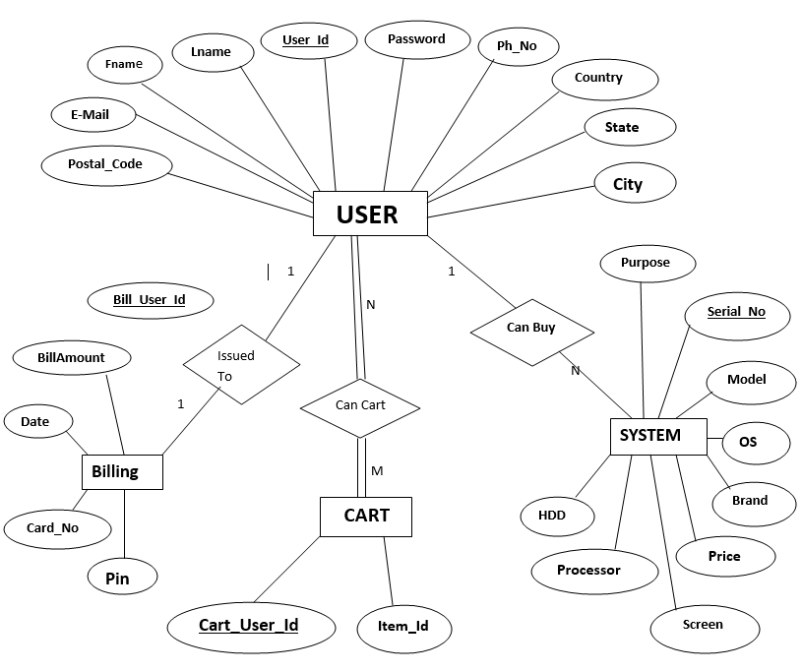

-**:SCHEMA DIAGRAM:-**

